**Hong Kong Institute of Vocational Education**

**(Tuen Mun)**

**Department of Information Technology**

**HD in Software Engineering (IT114105)**

**Module Code: ITP4506**

**Human Computer Interaction and GUI Programming**

**Project System Documentation**

**Date: 20-11-2020**

**Class : 2A**

**Group : S09**

|  |  |  |  |
| --- | --- | --- | --- |
| **Student ID** | **Name** | **Contribution** | **Signature** |
| **190001623** | **Cheung King Hung** | **50%** |  |
| **190117183** | **Lo Yee Kit** | **50%** |  |



**Contents**

1. User Analysis 4

1.1. User Characteristics 4

1.1.1. Learning style 4

1.1.2. Tool preferences 4

1.1.3. Physical differences 5

1.1.4. Cultural differences 5

1.1.5. Knowledge of job 6

1.1.6. Application familiarity 6

1.1.7. Primary and secondary users 6

1.2. Techniques for observing and listening to users 7

1.3. Environment Analysis 8

1.4. Recruiting Users 9

1.5. Task Analysis (HTA) 10

2. Web Design Concepts 11

Mental Model 11

Affordance 13

Content Organization 15

Visual Organization 16

Navigation 18

# User Analysis

## User Characteristics

### Learning style

**Do-then-read**

Because property websites are usually only visited by potential seller and buyer, and the information is single and not very complicated.

### Tool preferences

**Search**

Users often use the search function when looking for suitable property. Price, area, and location attribute are the main criteria of buying property or set selling price.

### Physical differences

Potential buyers and sellers are all over 30 years old, and they rarely use personal computers. When designing a website, consider the usability for use on a smartphone.

The website should be able to adjust the font and image size automatically on different devices.

### Cultural differences

Since the educational level of potential buyers and sellers are greatly different, the website’s functional words should be as simple as possible and use icon to guide them. It is suggested that the website should setup Chinese and English language option.

### Knowledge of job

**For** **Property Agent and Company Manager**

Since this is the website they use in their job, the backend system should focus on Usability rather than Appeal.

### Application familiarity

For novice, the website should pop up prompts after completing key things to prevent unexpected action due to unfamiliar system.

### Primary and secondary users

Primary users: **Property Agent , Company Manager**

Secondary users: **Seller, Buyer, Guest User**

## Techniques for observing and listening to users

**Focus group**

* A group of people are asked about their perceptions, opinions, beliefs, and attitudes towards a product or service

When developing this website, company manager, some agent and client with higher education are invited to discuss the web design.

* To Ensure the quality of the comment
* Understand the needs of different potential users

## Environment Analysis

Potential buyers and sellers are all over 30 years old, and they rarely use personal computers. When designing a website, consider the usability for use on a smartphone.

The website should be able to adjust the font and image size automatically on different devices.

## Recruiting Users

Design thinking should be considered in the development process. Designers should actively communicate with potential users and make system prototypes for the user to use so that they can get practical suggestions in the early stage of website development to avoid wasting time.

## Task Analysis (HTA)

Hierarchical Task Analysis

* Start with a user goal which is examined and the main tasks for achieving it are identified
* Tasks are sub-divided into sub-tasks. These are grouped as plans which specify how the tasks might be performed in practice.
* The task analysis procedure allowed areas of usability improvement to be identified and then addressed with alternate interface prototypes

Example of HTA – Add new property

To add new property from the website

* + - 1. Browse to the website
      2. Click login button
      3. Login as property agent
      4. Click Add property of sidebar
      5. Enter property attribute
      6. Click **Confirm!** Button

# Web Design Concepts

## Mental Model

The mental model aims to design the website according to what user think about and what process they want in the function of the website.

In the project, the website designed with the consideration of user’s habit and the normal experience in a property website. The followings are the example of Mental Model:

User would see the property just get in the page:

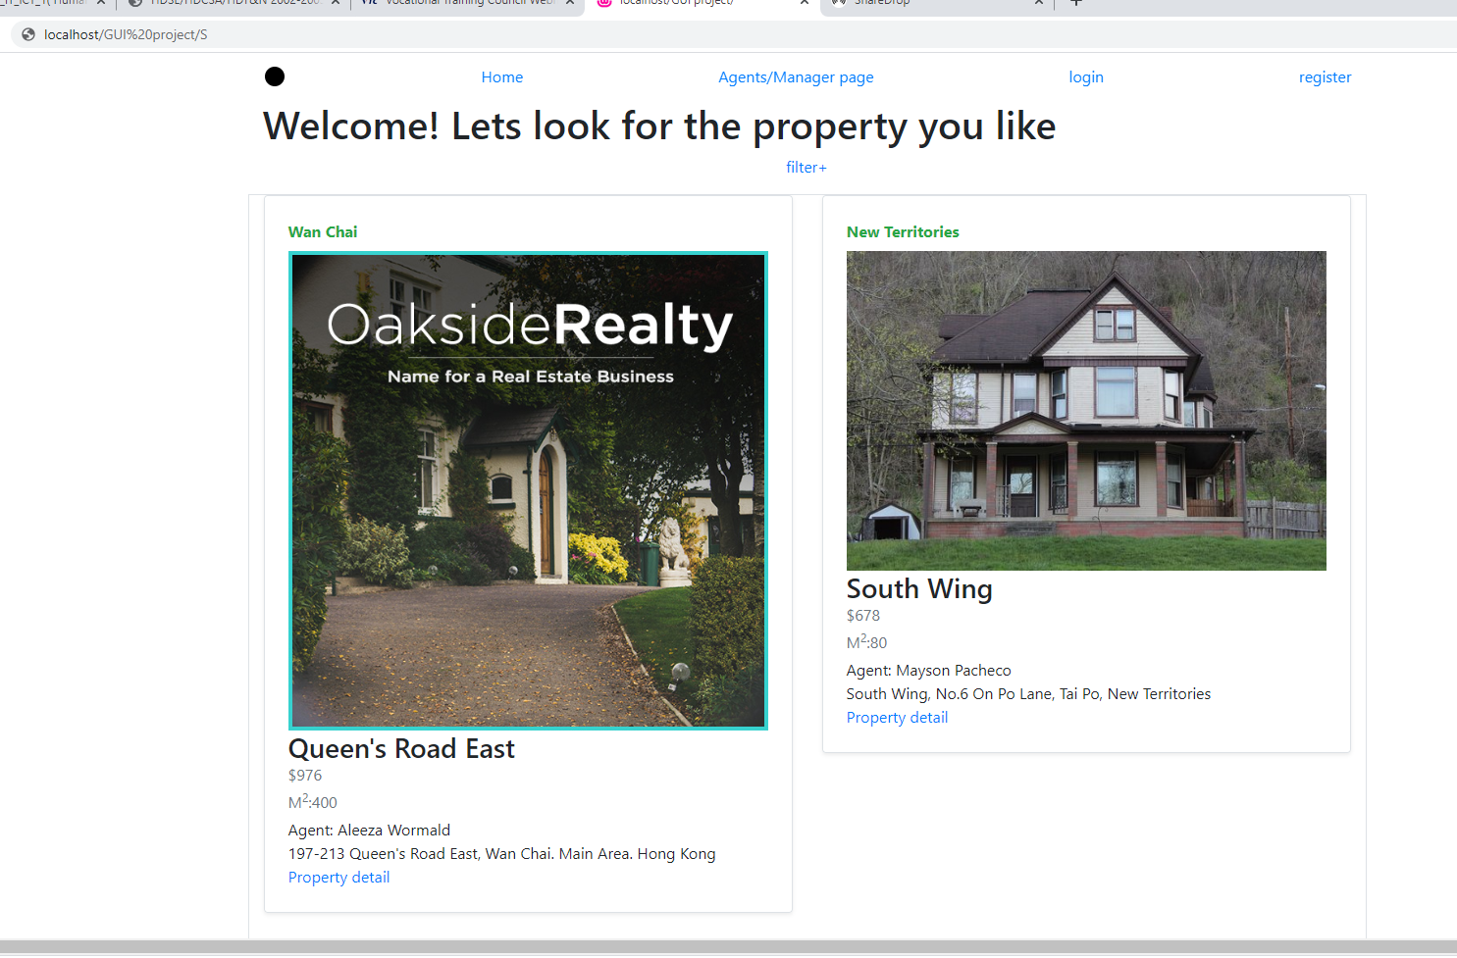

User can use the filter to search the popper information:

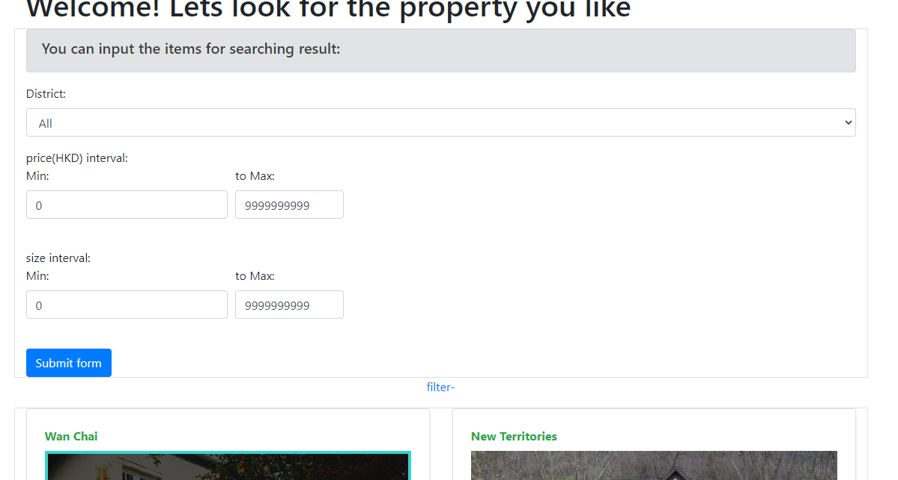

An alert will show if the input includes error content before submit:

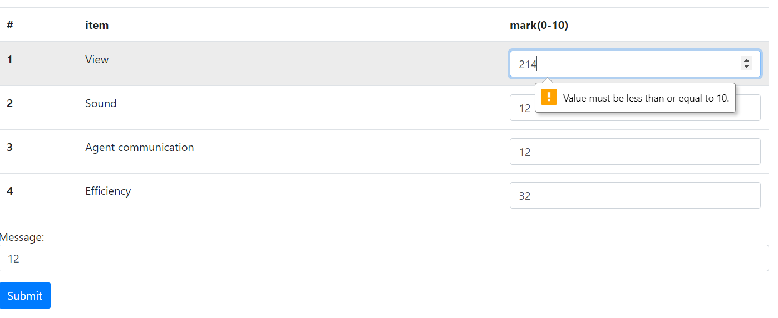

## Affordance

Affordance aims the function items should run on the way that it normally be. The characteristic of the functions should provide the corresponding function. A different usage of the function, button and any object will highly confuse the user.

Submit button can submit the form. A message would display if successfully submitted:

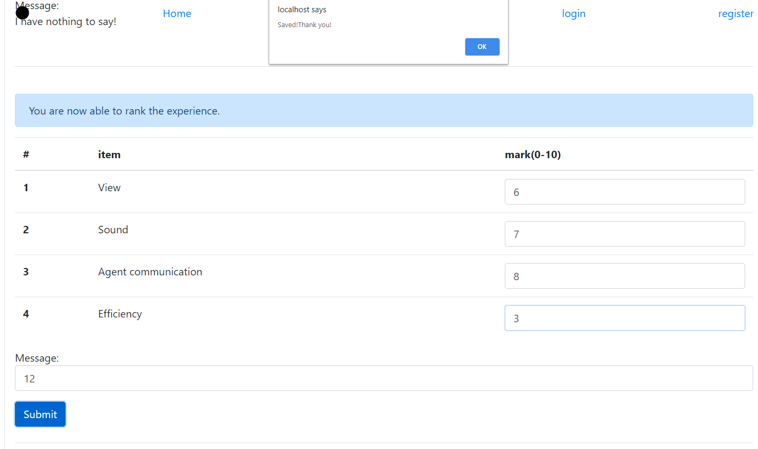

After enter the correct username and password, the website would direct to the corresponding website by their position:

(Left: login page, Right: after login)

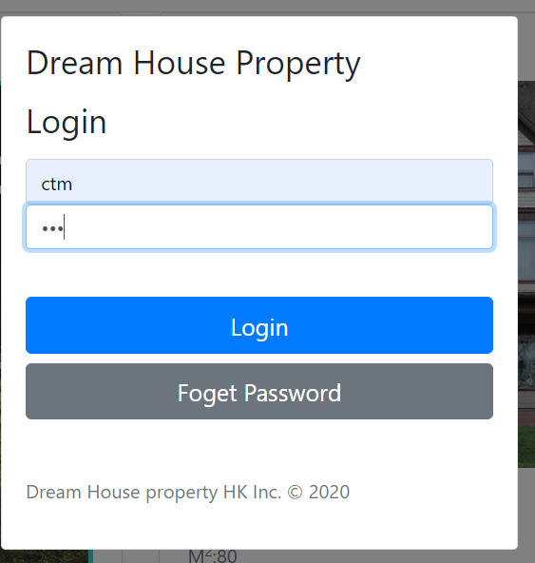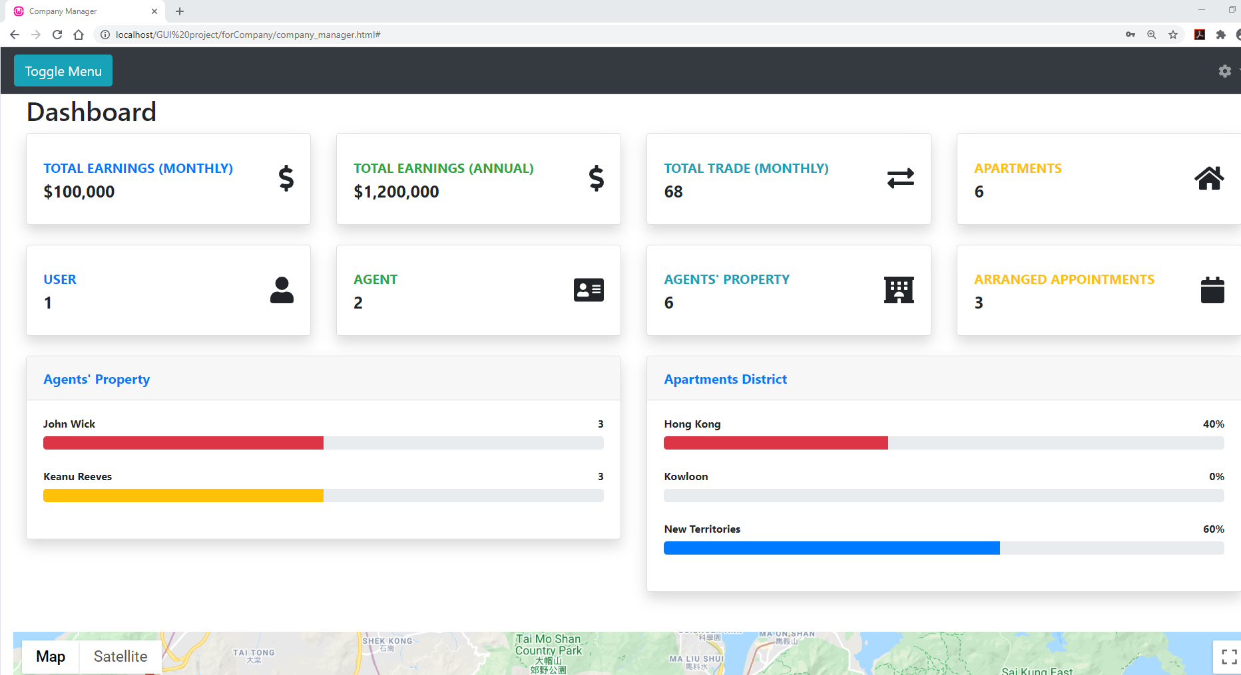

## Content Organization

The content Organization aims to group the different information in the clear way. The data of the same information should be formed, grouped, or listed with the way of Alphabetical or Chronological. A group of data should place in a special area by the type of information.

The properties are formed for displaying:

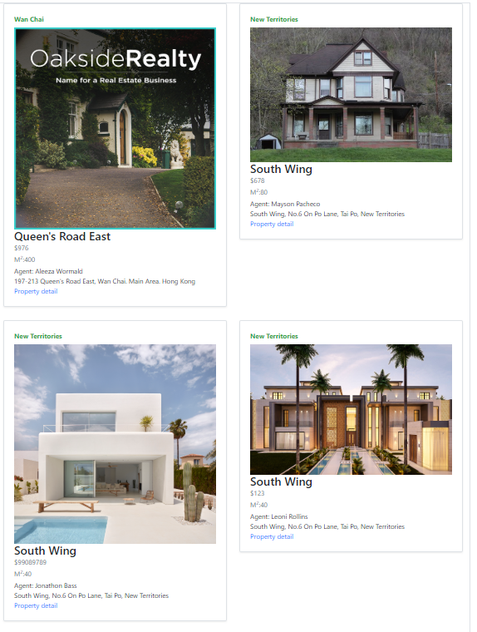

The data of user’s information is listed in a page with the same formation:

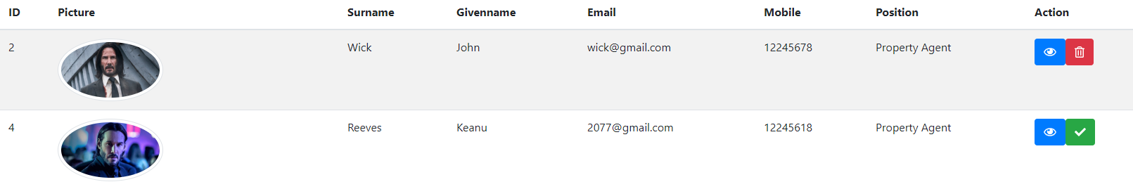

## Visual Organization

Good visuals organization can make the website more effective. Users can easily find the information. As a result of nice appearance, the link is easy to find. Proximity, Alignment, Consistency and Contrast are the 4 principles of website design.

The information of each property box is left aligned:

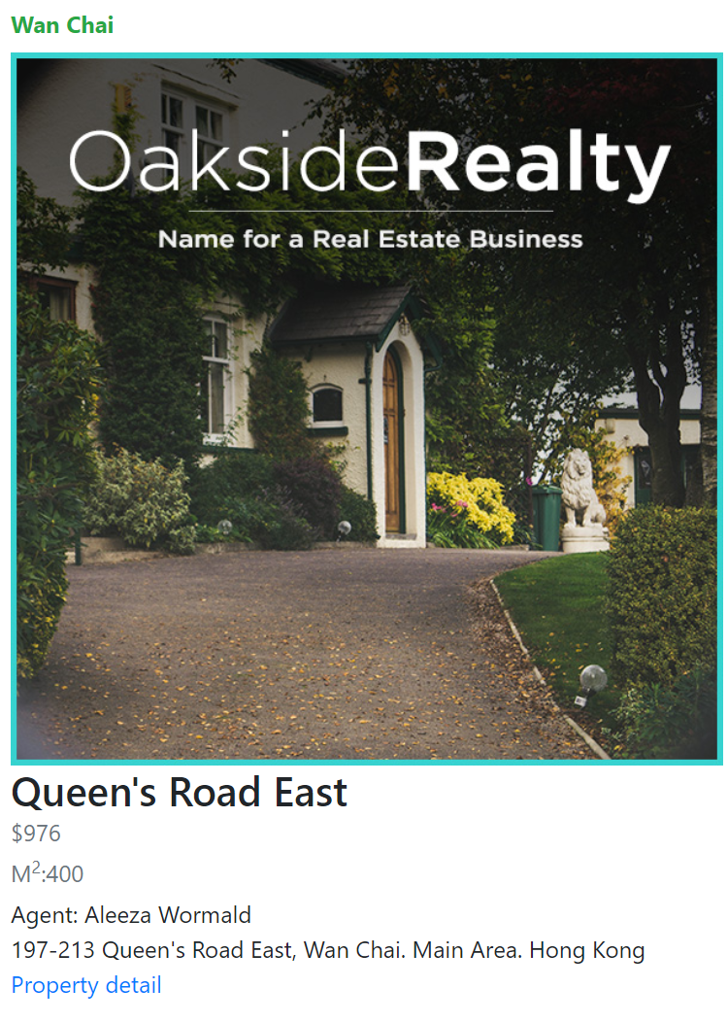

The items relate to the appointment data are group in the right side and they keep consistence by the list:

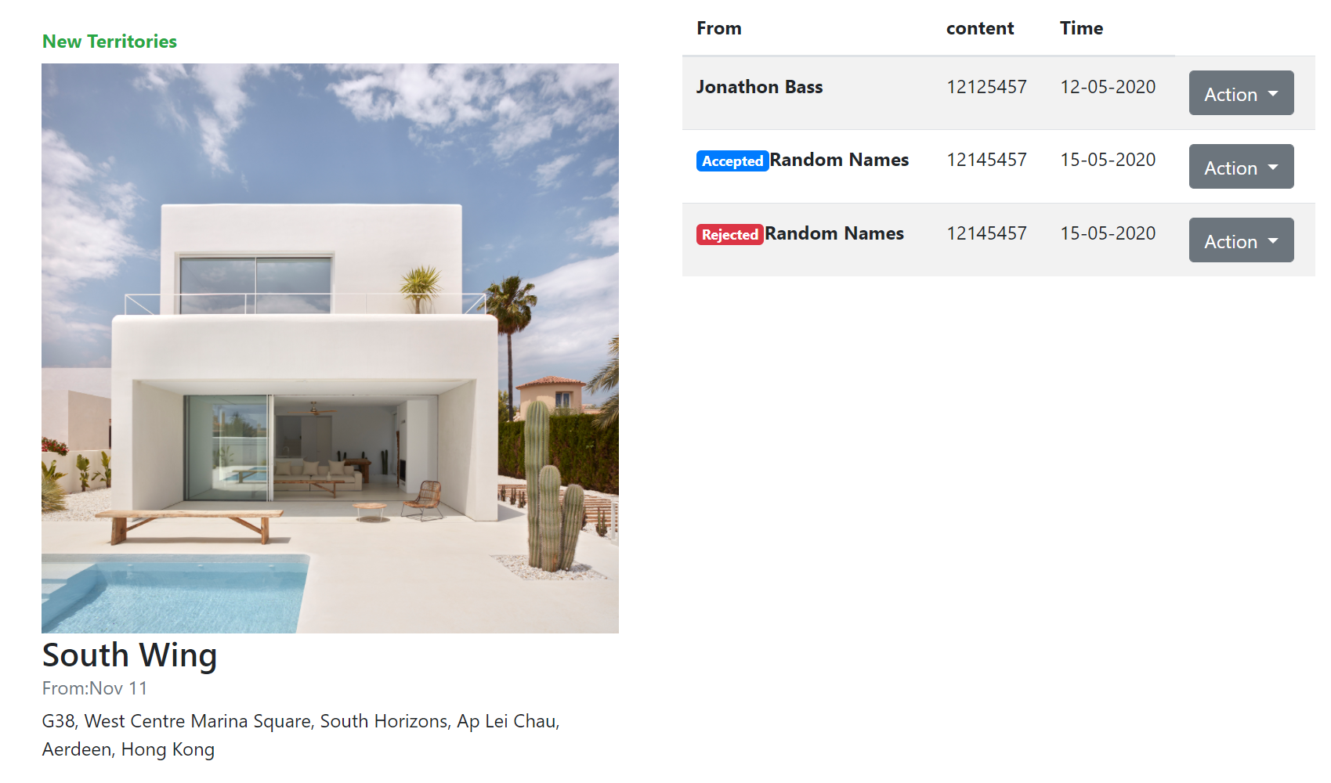

## Navigation

The navigation bar of a website plays an important role. It is helpful for the users to look for the information page they need especially when the website is big, complex or include many functions.

The navigation bar for agent and company:

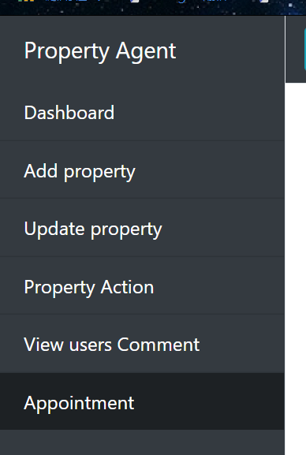

The navigation bar for normal users:

